**UPDATE ON SWCD ACTIVITIES FOR 2022**

1. **TRAINING ON SOAP MAKING FOR PWDs**

**Training Objectives**

The objectives of the program were to enable participants acquire various skills and techniques into the making of Bar Soap, Liquid Soap, After Wash and Parazone.

Specifically, the training was to offer participants the opportunity to:

* Differentiate types of Bar Soaps, Liquid soaps, After Wash and Parazone.
* Identify the specific uses of various products.
* Know the basic raw materials in making various products and their source in Ghana.
* Learn various techniques in soap making and other products.

To be able to make a variety of Soaps. The Department invited forty (40) female PWD’s from the various Associations to participate in the soap making training from the 1st of November to 4th November, 2022.

**GALLERY**

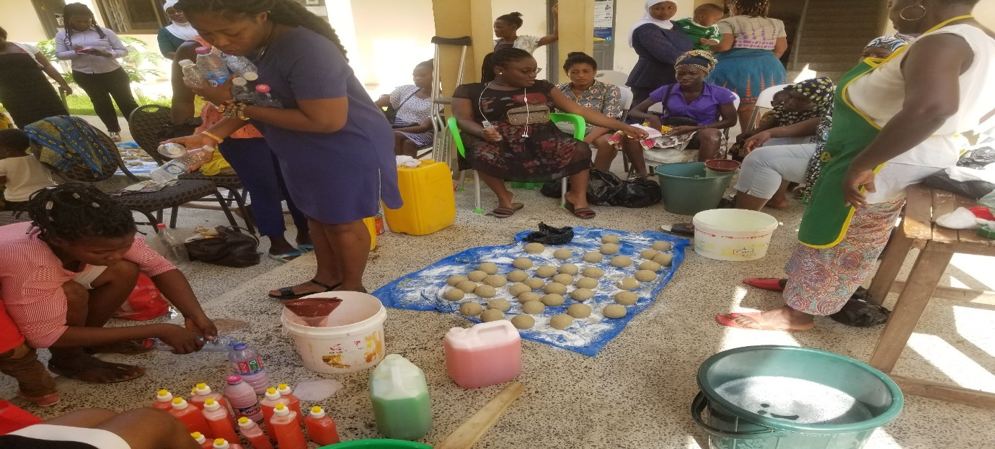

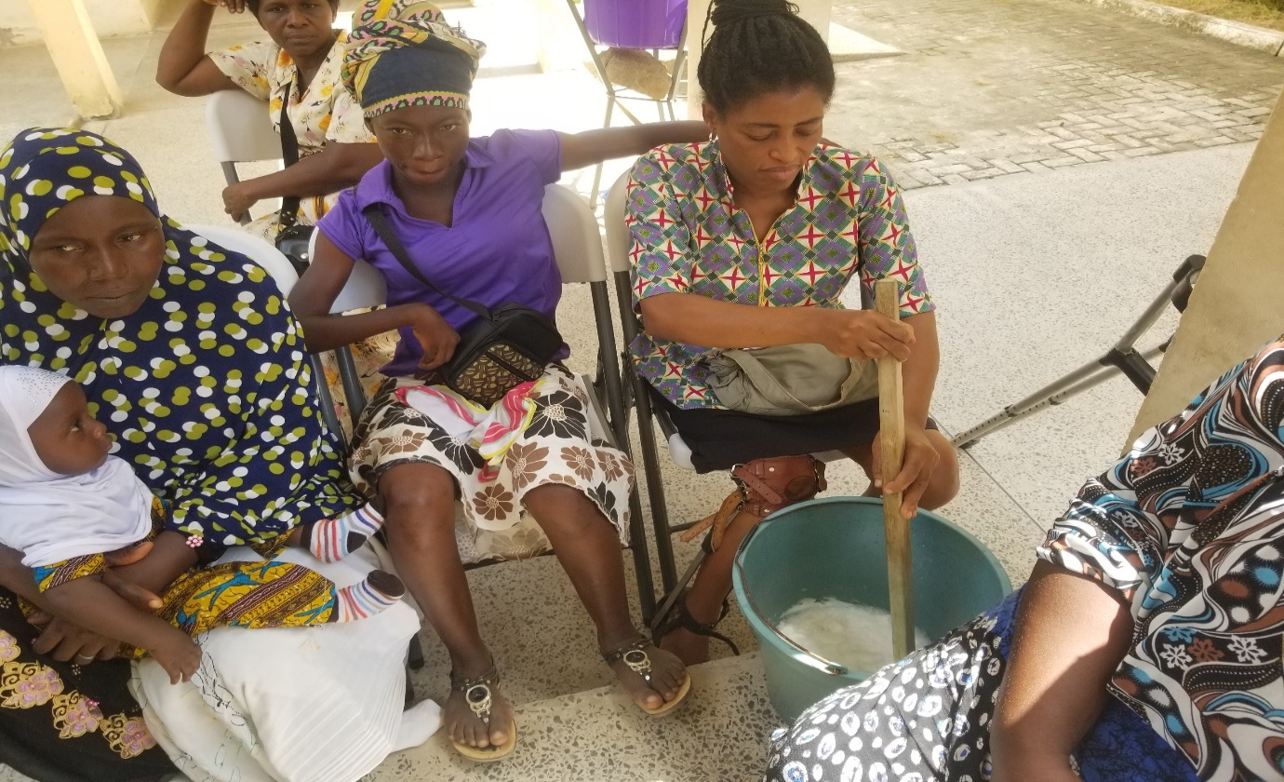

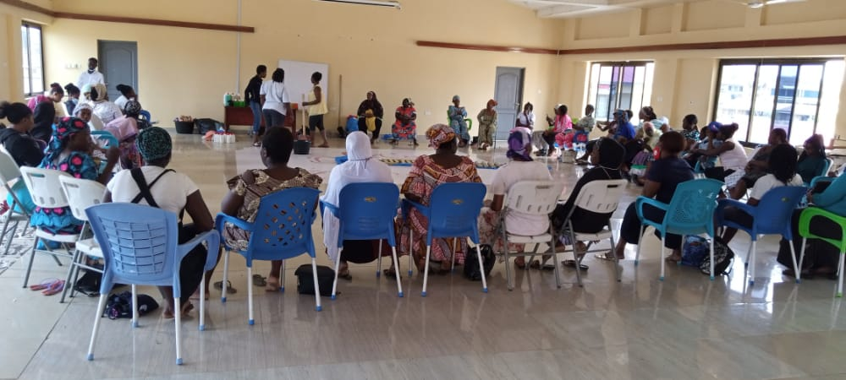

**2.**

**SKILLS TRAINING IN THE MAKING OF FACINATOR FOR PERSONS WITH DISABILITY (PWD) AND OTHER WOMEN’S GROUP**

**AIMS/OBJECTIVE OF THE TRAINING**

This training was geared towards helping the vulnerable women and out of school youth within the municipality and Persons with Disabilities (PWD) gain some requisite skill in making fascinators, key holders, bridal feather fan, hair bands etc. These employable skills will help these vulnerable women and PWD’s to create jobs for themselves and generate some income to cater for their needs as well as their families.

**VENUE, DATE FOR THE TRAINING**

|  |  |  |  |
| --- | --- | --- | --- |
| **S/NO** | **GROUP** | **VENUE** | **DATE** |
| 1 | Persons with Disability (PWD) GSPD | EKMA | 5th October, 2022 |
| 2 | Vulnerable & out of school youth | KWESIMINTSIM | 6th October, 2022 |
| 3 | Women’s group | EFFIAKUMA | 7th October, 2022 |

**NUMBER OF PARTICIPANTS**

At the end of the training 57 vulnerable women and out of school youth within the municipality and Persons with Disabilities (PWD) were trained in how to make bridal fan, fascinators, key holders etc. Out this total number three (3) of them were male and the remaining fifty-four (54) were female.

|  |  |  |  |  |
| --- | --- | --- | --- | --- |
| **S/NO** | **GROUP** | **MALE** | **FEMALE** | **TOTAL** |
| 1 | Persons With Disability (PWD) | 3 | 8 | 11 |
| 2 | Vulnerable and Out of School Youths | 0 | 12 | 12 |
| 3 | Women’s groups | 0 | 34 | 34 |
| **TOTAL** | | **3** | **54** | **57** |

**GALLERY**

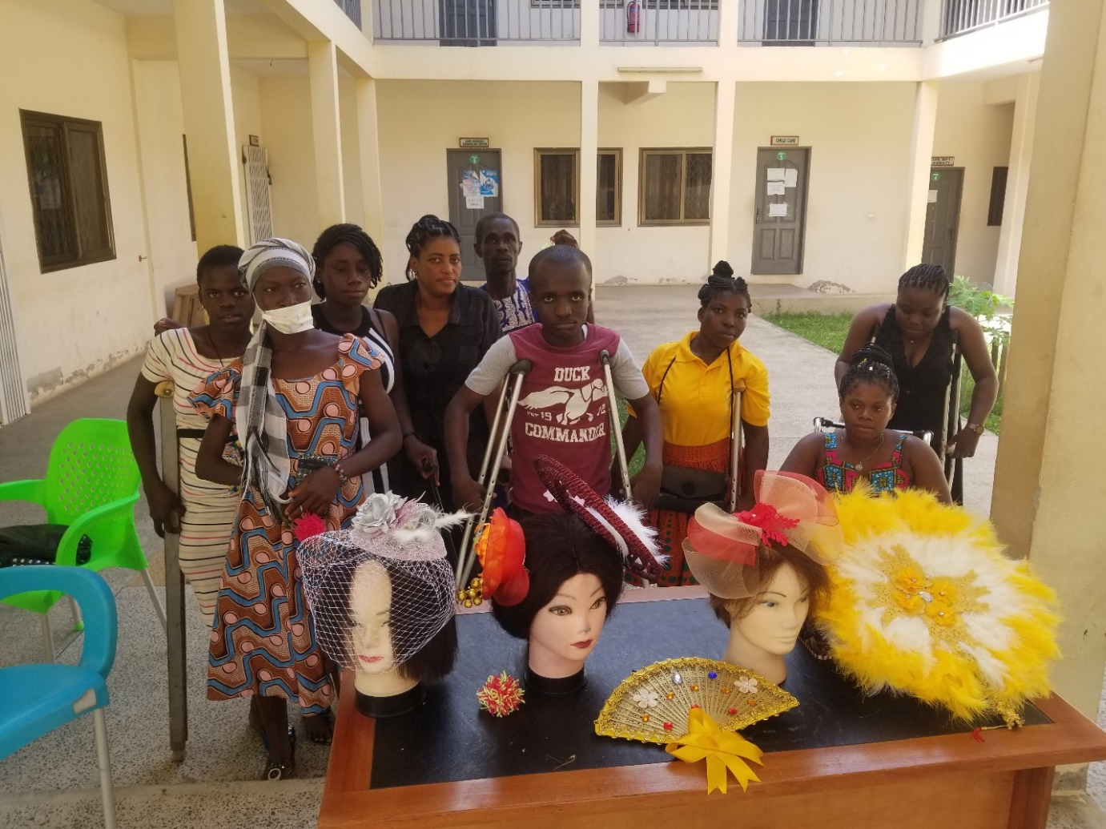

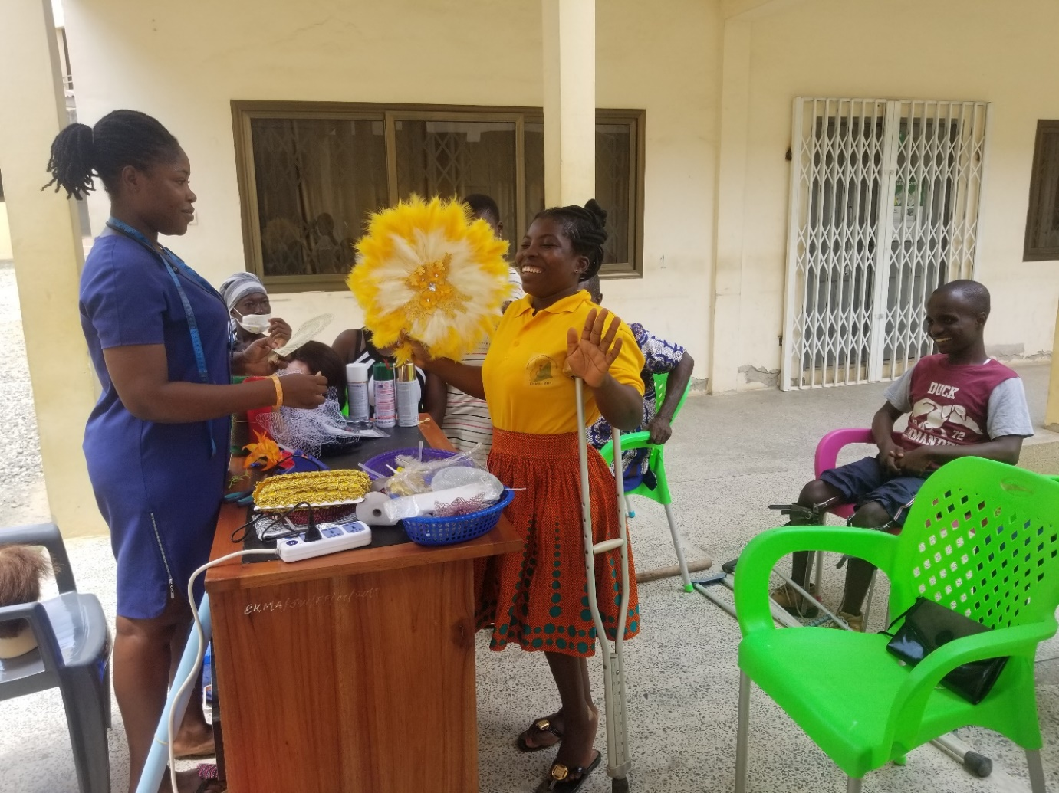

**DISBURSEMENT OF ITEMS TO PWD’S**

The Department undertook two disbursement exercise for the year 2022, in August and December, 2022.

* The total number of beneficiaries for the PWD disbursement for the year was twenty-three (23)
* The total amount of money used for the PWD disbursement for the year was Seventy-Four Thousand Nine Hundred and Seventy-Two Ghana Cedis **GH¢ 74,972.00**
* Male beneficiaries for the PWD disbursement for the year was eight (7)
* Female beneficiaries for the PWD disbursement for the year was wen fifteen (14)

**The categories of PWD and their number of beneficiaries are as follows:**

* + Deaf – 4
  + Physically challenged – 12
  + Intellectual disability – 2
  + Blind – 5

The beneficiary communities within the Municipality are:

* 1. Effiakuma/Effia
  2. Assakae
  3. Kwesimintsim
  4. Whindo
  5. Apremdo
  6. Anaji
  7. Tanokrom

**Below in the table are the items and the number of beneficiaries disbursed for the year 2022.**

|  |  |  |
| --- | --- | --- |
| **S/No** | **Items** | **Number Of Beneficiaries** |
| 1 | Deep freezers | 3 |
| 2 | School items/fees | 4 |
| 3 | Provisions | 8 |
| 4 | Cosmetics | 1 |
| 5 | Rubber slippers | 1 |
| 6 | Hair dressing items | 1 |
| 7 | Stationery | 1 |
| 8 | Hair product | 1 |
| 9 | Second hand clothing | 1 |
| 10 | Soap & detergent | 1 |
| 11 | Transtibial Prosthesis Men Dynamic Prosthetic Foot and standard Cosmetic | 1 |
| **Total** | | **23** |

The committee also approved for a capacity training for the members as well as the PWD association leaders within the Municipality on TVET for PWDs. This decision was taken on the note that most PWDs do not utilize or put to good use the items give to them and as such the committee members as well as the association heads needs to be educated on the role and importance of the TVET for the benefit of the PWDs, so that they can in turn educate their members to take advantage of learning some employable skills in order to get employed or create their own jobs.

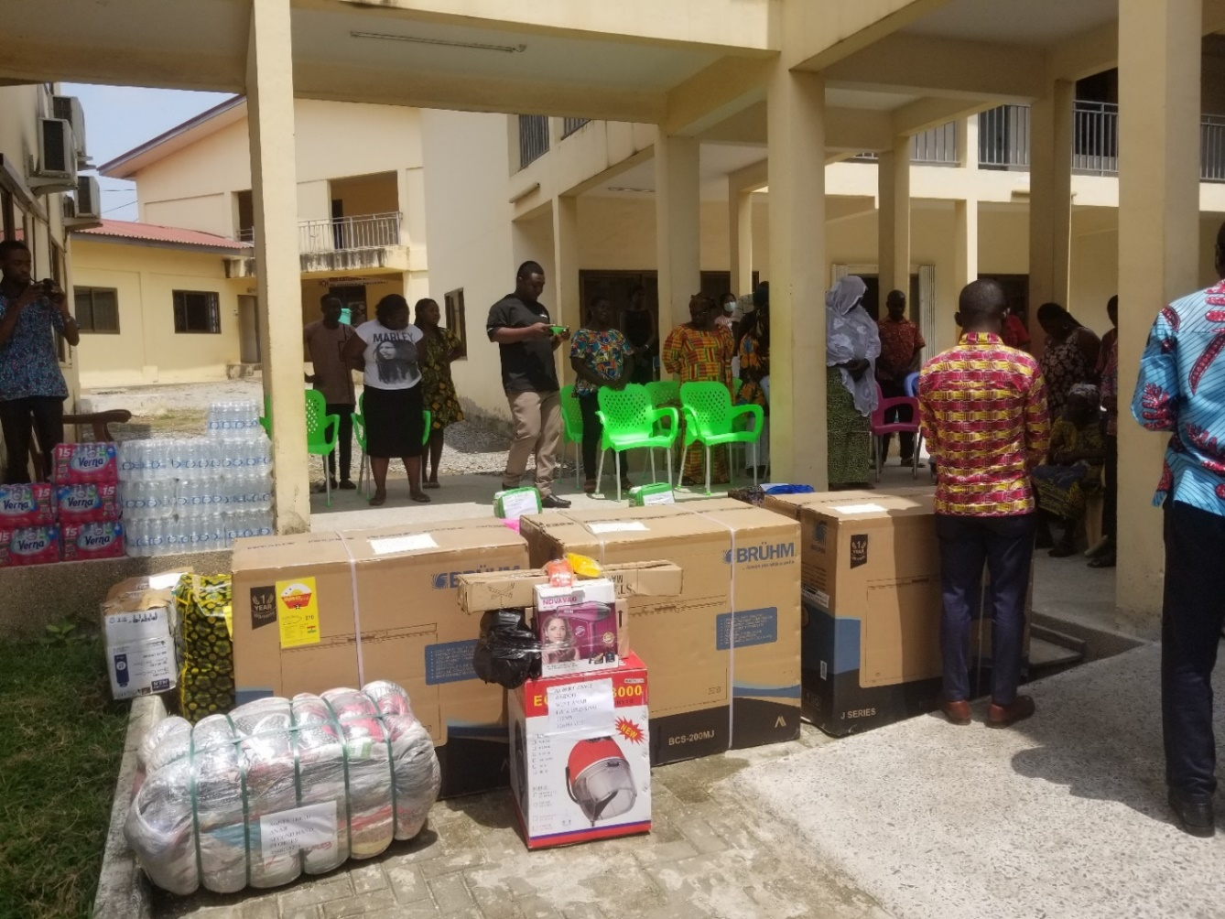

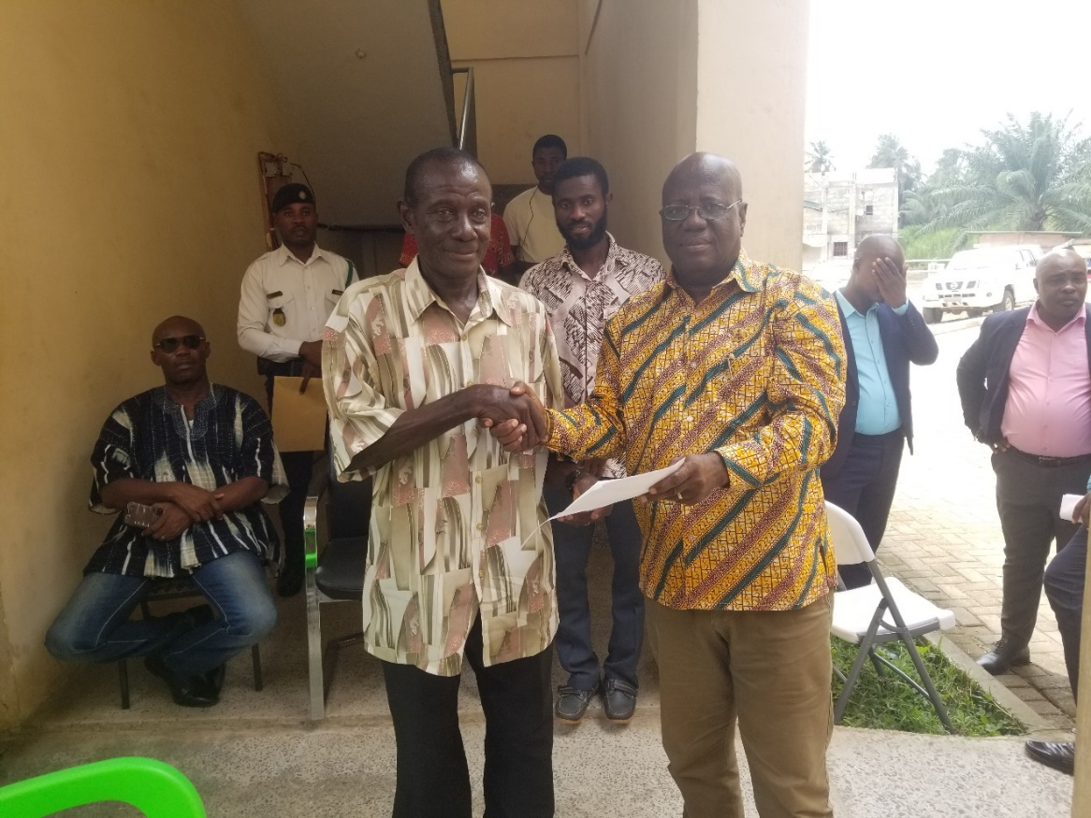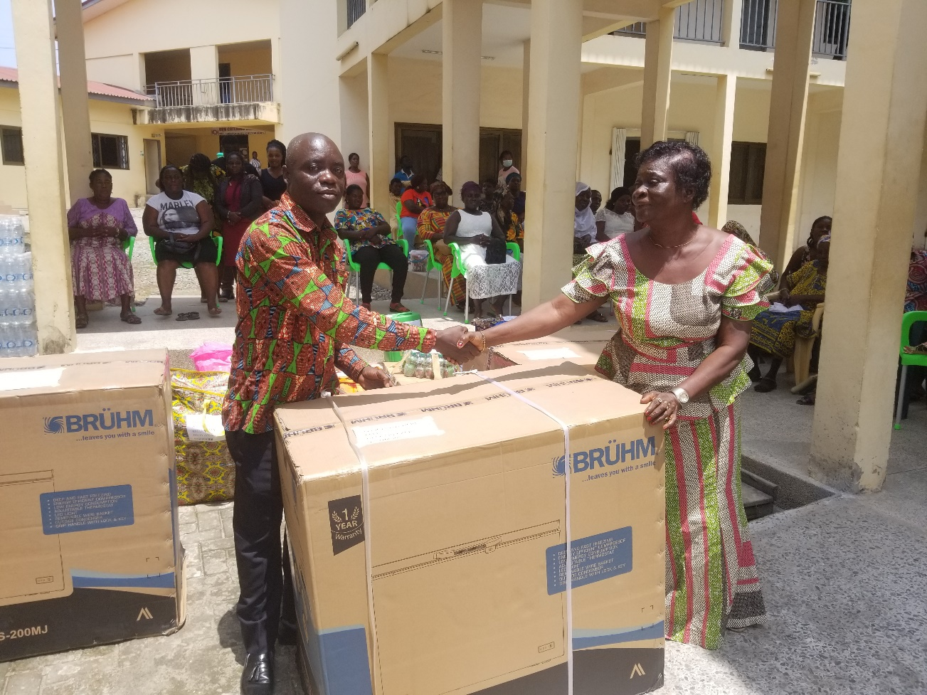

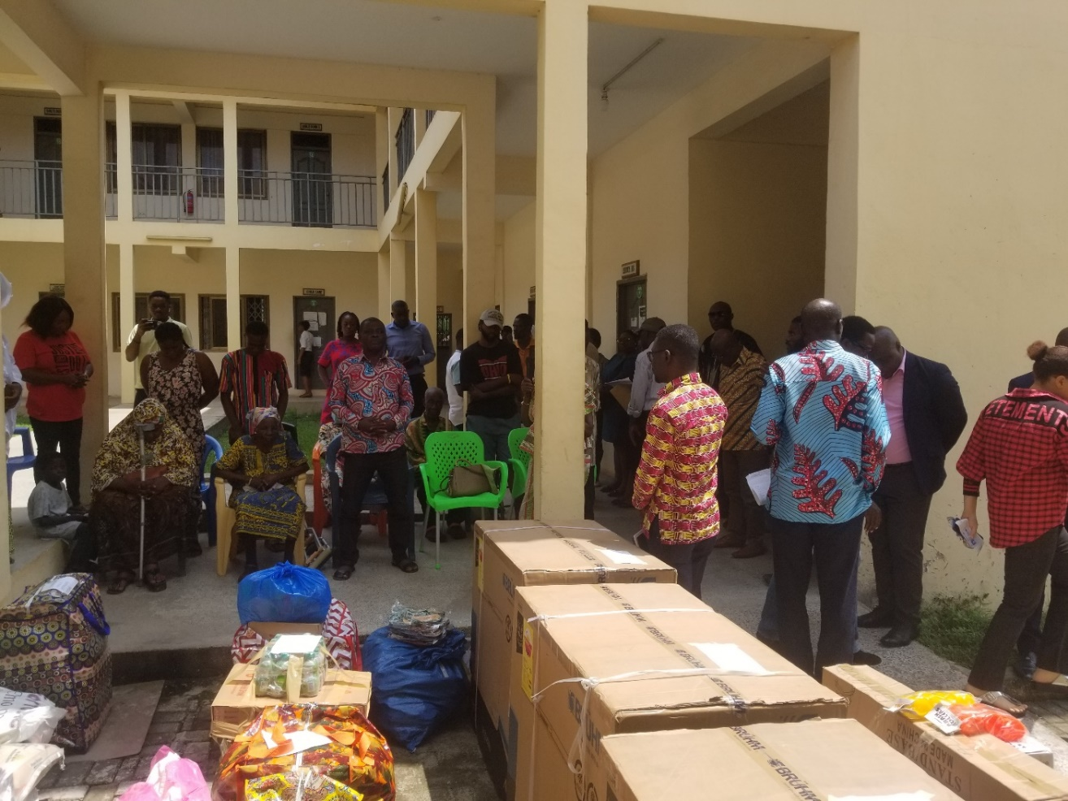

**PUBLIC SENSITIZATION ON THE DOMESTIC VIOLENCE ACT,2007 (ACT 732), GENDER EQUALITY AND GENDER MAINSTREAMING THE MAIN AIM OF THE PROGRAM WAS TO EDUCATE THE PUBLIC ON THE CONTENTS OF THE DOMESTIC VIOLENCE ACT, 2007.**

The objectives for the program was to sensitize on:

1. The meaning, types of Domestic Violence according to the Domestic Violence Act.
2. The Effects of Domestic Violence
3. To encourage the populace to report all forms of abuse and the places to report.
4. To sensitize on gender equality gender norms and some harmful gender norms.

**VENUES, DATE AND TIME FOR THE PROGRAMME**

Three (3) Markets, two (2) lorry terminals and a Community Information Center was visited for the exercise. They are as follows:

|  |  |  |  |  |
| --- | --- | --- | --- | --- |
| **S/N** | **VENUE** | **DATE** | **TIME** | **OFFICERS** |
| 1. | Kwesimintsim Lorry Terminal | 13th July, 2022 | 10am-12pm | Benjamin Amenfi |
| 2. | Jubilee Market | 15th July, 2022 | 10am-12pm | Yusif Osman |
| 3. | Effiakuma | 19th July, 2022 | 10am-11:45am | Alimatu Sadia |
| 4. | Effiakuma Community Information Center | 19th July, 2022 | 1pm-1:45pm |  |
| 5. | Assakae Market | 26th July, 2022 | 10:30am-12:20pm |  |
| 6. | Apremdo Lorry Terminal |  | 11am-12:15pm |  |

**ACHIEVEMENTS**

1. All the market centers and lorry terminals selected for this programme was visited for the programme.
2. Interactions and feedback from the public was encouraging.
3. Questions were asked/counsel was given.
4. Some of the people shared stories of how abuse victims sort for state agencies services and was assisted accordingly and this turn out to encourage a lot of the masses.
5. Some market women came to the office (Social Welfare) to report cases after the sensitization programme.

**CHALLENGES**

The main challenge was a vehicle and funds for the programme.

**RECOMMENDATION**

The recommendations are as follows;

Mass campaigns on the Domestic Violence Act using community engagements and radios on the negative effects of Domestic Violence.

Support or training for women and girls, especially out of school girls.

Media engagement to support positive gender norms and equitable power relations.

**GALLERY**

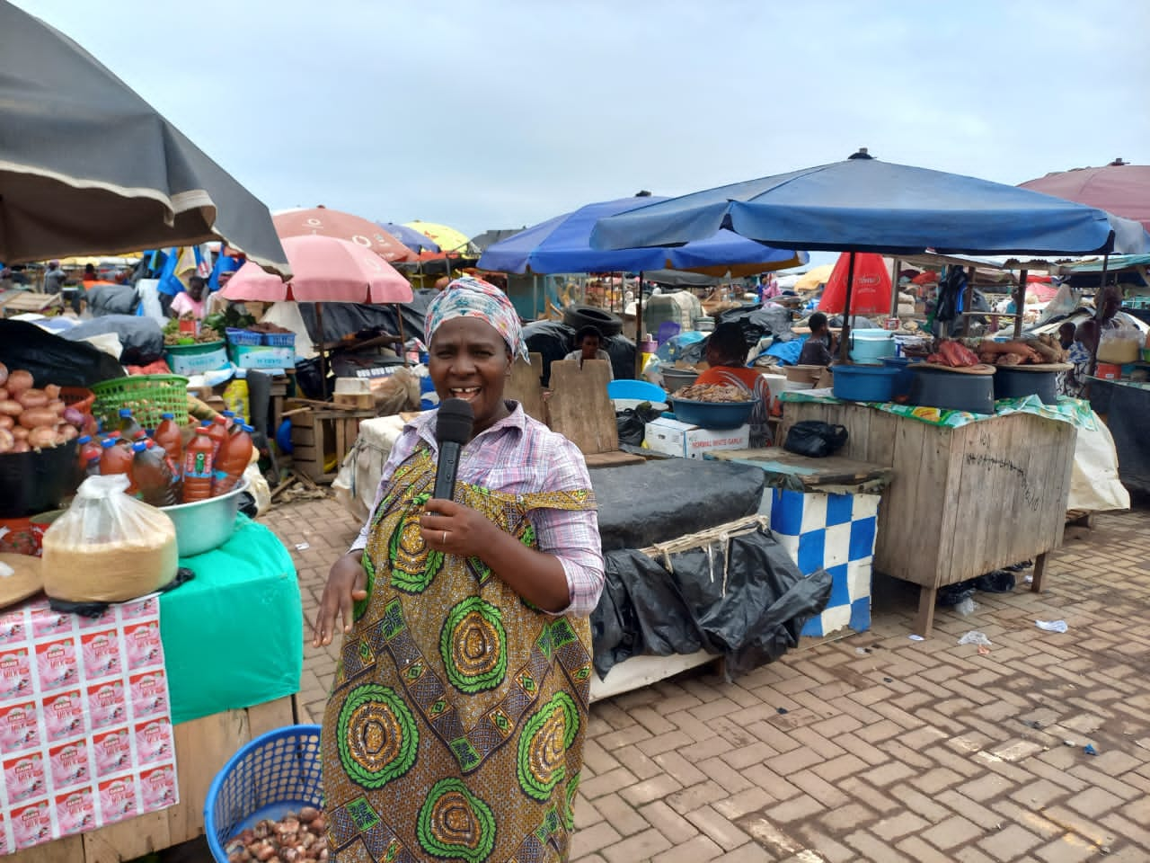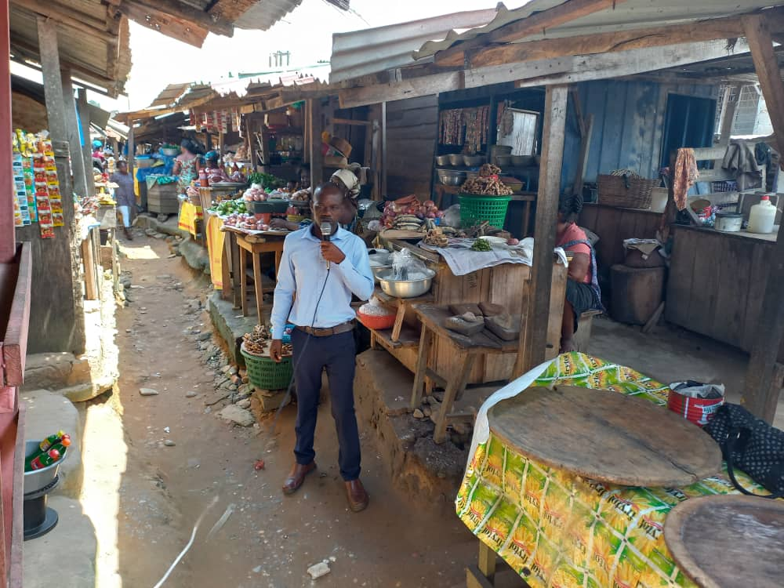

**MASS EDUCATION ON RAPE AND DEFILEMENT**

**AIMS AND OBJECTIVES OF THE PROGRAM**

The aims and objectives of the program are for general public to

1. Understand what constitute defilement (in accordance with the Ghana Criminal Code, 1960, sexual offences)
2. Describe the possible physical signs as well as Behavioural signs exhibited in children who have been sexually abused.
3. Learn about who paedophiles and their characteristics.
4. Know the institutions to report cases of child sexual abuse and also to receive support for the victims.

**DATE, VENUE AND TIME FOR THE PROGRAM**

|  |  |  |  |
| --- | --- | --- | --- |
| **S/N** | **DATE** | **VENUE** | **TIME** |
| 1. | 10th May, 2022 (Tuesday) | Spice FM | 9am – 11am |
| 2. | 26th May, 2022 (Thursday) | Anaji M/A School (Parent Teacher Association) | 10am – 11am |
| 3. | 28th May, 2022 (Saturday) | Angel FM | 3pm – 5pm |
| 4. | 7th June, 2022 (Tuesday) | Connect FM | 9;30am 10:00am |
| 5. | 9th June, 2022 (Thursday) | Big FM | 9:00am- 10am |
| 6. | 15th June, 2022 (Wednesday) | Azay FM | 8:30am- 9:30am |

**GALLERY**

